

Faculty of Engineering and Applied Science
SOFE3720: Introduction to Artificial Intelligence
Winter 2026
Due Date: April 13th, 2026

Intro to Artificial Intelligence Final Project
CRN: 74674
Group 9

Student Name | Student ID
Armaan Parmar | 100877218
Farzad Shahdad | 100861389
Waliullah Khan Mohammed | 100865624

1. Introduction 3
2. Problem Formulation 3
3. AI Algorithm Implementation 4
4. System Design 5
5. Experimental Evaluation 8
6. Software Engineering Assessment 9
7. Ethical and Professional Considerations 9
8. Limitations and Future Work 10
9. Conclusion 10
Appendix A. File Responsibilities 11

Github Link:
https://github.com/armaan-p22/8-puzzle-solver

1. Introduction: What is the 8-Puzzle Solver?
The 8-puzzle is essentially an A.I search problem that involves a 3x3 grid with 8 out of the 9 tiles numbered and filled with one tile empty. The goal of this puzzle is to rearrange the tiles from a random starting state to a specific target state by sliding the tiles into the blank space, one move at a time. The puzzle visually seems quite simple but the number of possible configurations is what makes it complicated, making it a useful example for demonstrating the importance of different search strategies.

This solver implements three search algorithms: Breadth-First Search (BFS), Depth-First Search (DFS), and A* Search using the Manhattan distance heuristic. The program is structured across multiple modules:
- Board.py defines the node and state representation
- Algorithms.py contains the logic for each search method and path construction
- Utils.py provides helper functions such as heuristic calculations and board display
- Main.py serves as the command-line interface, handling input validation and comparing the performance of the algorithms.

2. Problem Formulation
2.1 Problem definition
The task of this project is to find a sequence of moves that transforms an initial 8-puzzle state into the goal state (1, 2, 3, 4, 5, 6, 7, 8, 0 reading from left to right and top to bottom), where 0 represents the blank tile. A solution is successful when all of the tiles are in their correct positions.

2.2 State space / input representation
Each board state is represented as a one-dimensional tuple of length nine. For example, the goal configuration is stored as (1, 2, 3, 4, 5, 6, 7, 8, 0). Using tuples makes the states immutable and hashable, which allows them to be stored in sets for explored-state tracking.

2.3 Actions
The actions include moving the blank tile UP, DOWN, LEFT, or RIGHT as long as moving the tile keeps it in the bounds of the 3x3 grid.

2.4 Constraints
- Only one tile can be moved at a time, and it must slide into the blank space.
- Moves must stay in the 3x3 board boundaries.
- A valid input state must contain exactly nine numbers and include each value from 0 through 8 exactly once.
- The main.py file performs basic input validation for size of the grid, uniqueness of each value, and numeric conversion.

2.5 Cost and objective function
The path cost, denoted as g(n), represents the number of moves taken to reach the current state from the initial configuration. In the case of A* Search, the heuristic function h(n) is calculated using the Manhattan distance, which estimates how many moves each tile is away from its correct position in the goal state. A* combines these two values using the function f(n) = g(n) + h(n) to evaluate which node to explore next. The overall objective is to find the solution that reaches the goal state using the fewest possible moves.

2.6 Why AI is needed
Uninformed search methods can solve the puzzle in theory, but they become increasingly inefficient as the depth grows, since they need to explore a large number of states before reaching the goal. This is where AI-based approaches become valuable. Heuristic search incorporates problem-specific knowledge to guide the search toward more promising states. In this project, the Manhattan distance heuristic provides an estimate of how close a given board is to the goal configuration, enabling A* to find the best solutions while expanding significantly fewer nodes compared to BFS on the same problem.

3. AI Algorithm Implementation
3.1 Core techniques used
The final project uses three search strategies: BFS, DFS, and A*. BFS is included as an uninformed optimal baseline for uniform step costs, DFS is included as a depth-oriented uninformed baseline, and A* is the primary informed technique. This satisfies the requirement to implement and explain AI logic directly in code rather than relying only on external libraries.

3.2 A* algorithm logic
- Create a start node from the initial state with g_cost = 0.
- Compute h_cost using the Manhattan distance and push the start node into a min-heap frontier.
- Repeatedly remove the node with the lowest f_cost from the frontier.
- If the current node (board) matches the goal state, stop and work in reverse to get the steps taken to reach the goal state.
- Otherwise, generate all legal child states by moving the blank tile up, down, left, or right.
- For each child that hasn’t been explored yet, compute its heuristic and push it into the frontier.
- Continue until the goal state is found or the frontier is empty.

3.3 Code-level interpretation
The Node class represents each puzzle state, storing the current board configuration, the parent node that generated it, the action taken to reach it, and the associated cost values (g and h). The f_cost property computes the A* evaluation function, while the lt method allows Node objects to be properly ordered within Python’s heapq structure. The get_children() method generates all valid successor states by moving the blank tile in any allowable direction.

In algorithms.py, the a_star_search() function performs an informed search using a priority queue (heapq), whereas bfs_search() uses a double-ended queue to implement a FIFO approach, and dfs_search() relies on a Python list to function as a LIFO stack. Both BFS and DFS maintain a frontier_states set to prevent duplicate states from being added to the frontier. Additionally, the get_path() helper function reconstructs the sequence of moves and intermediate states by tracing back through each node’s parent until reaching the initial state.

3.4 Heuristic function
The Manhattan distance heuristic in utils.py loops through tiles 1 to 8, finds each tile's current and goal positions, converts those one-dimensional indices into row and column coordinates, and sums the vertical and horizontal offsets. The blank tile is excluded because it’s a placeholder used only for movement.

3.5 Additional implemented search methods
BFS guarantees a shortest solution when all moves have equal cost, but it expands a large number of states because it does not use domain knowledge. DFS explores one branch deeply before backtracking, in this implementation, children are processed in reversed order so the first generated move is popped first. DFS can still reach a goal, but it’s not optimal and can go through many unnecessary states before finding a solution.

The main.py driver ties the search methods together. It allows the user to run a default board or enter a custom board, validates the custom input, executes each algorithm in sequence, records execution time, and prints solution depth, nodes expanded, and the resulting move list.

4. System Design
The system follows a modular design, which is explicitly required by the project guidelines. State representation, search logic, utility functions, and user interaction are separated into focused modules. This improves readability, makes the project easier to demonstrate, and simplifies future extension such as adding a solvability checker or more advanced heuristics.

4.1 Use case diagram
The main actor is the user. The user can choose a default or custom board, launch the implemented search algorithms, and inspect the resulting move sequence and performance metrics. Internally, the solver computes heuristics, generates child states, and reconstructs the final path.
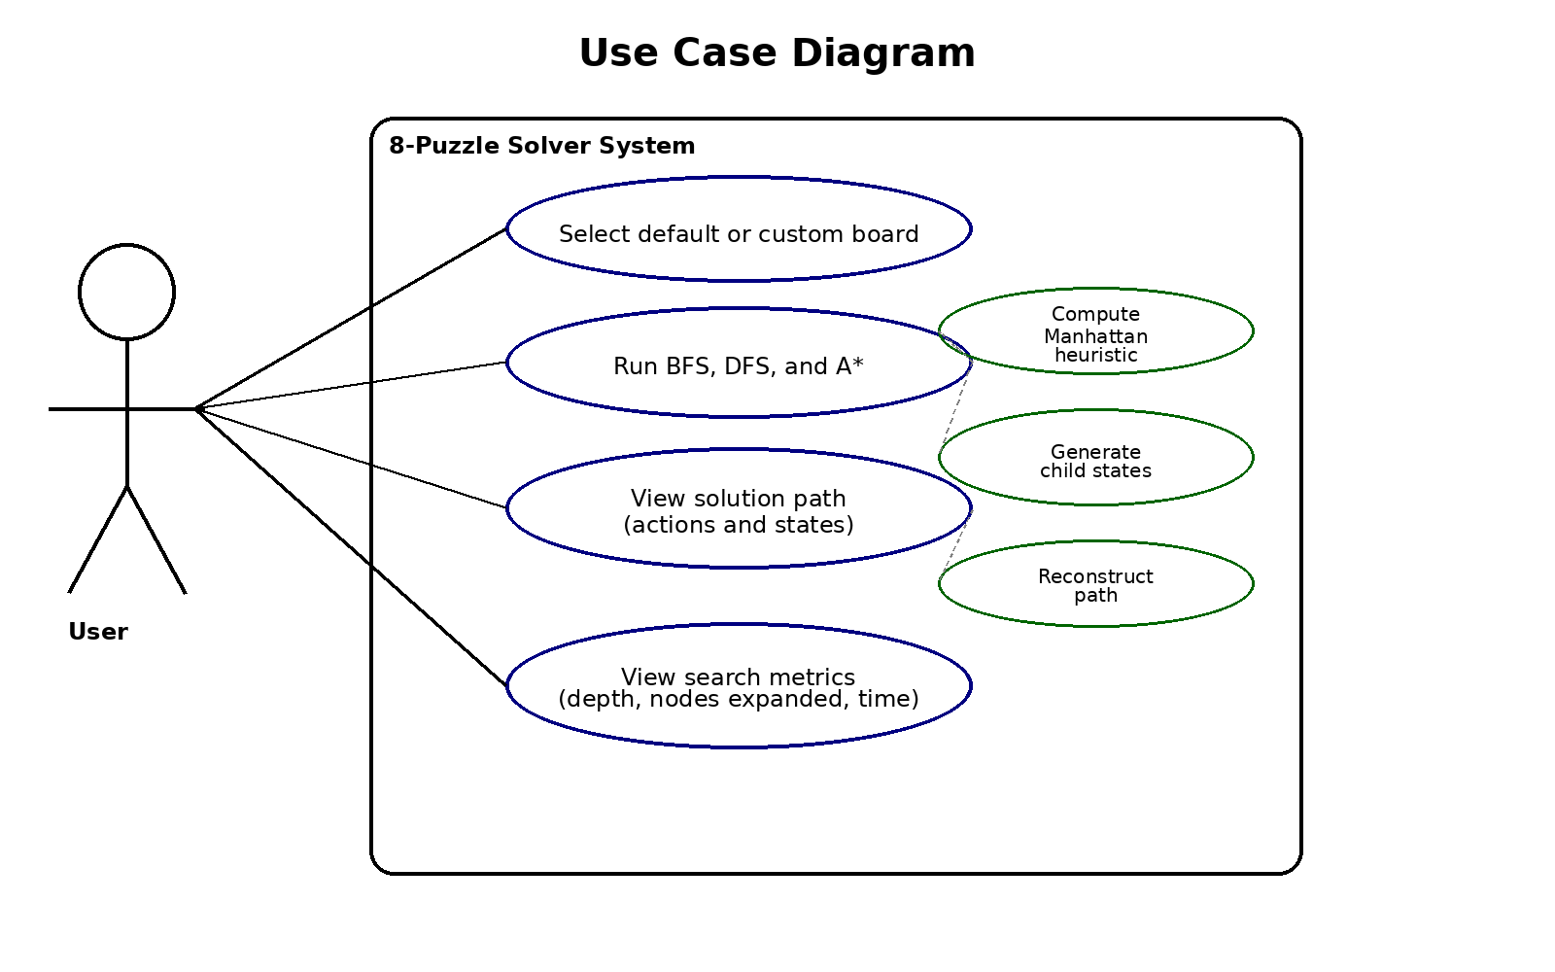
Figure 1. Updated use case diagram for the final 8-puzzle solver.

4.2 Class diagram
The project contains one primary domain class, Node, and three cooperating program modules. The class and module diagram shows how algorithms.py creates and expands Node objects, how utils.py provides heuristic support, and how main.py is the entry point that executes the application.
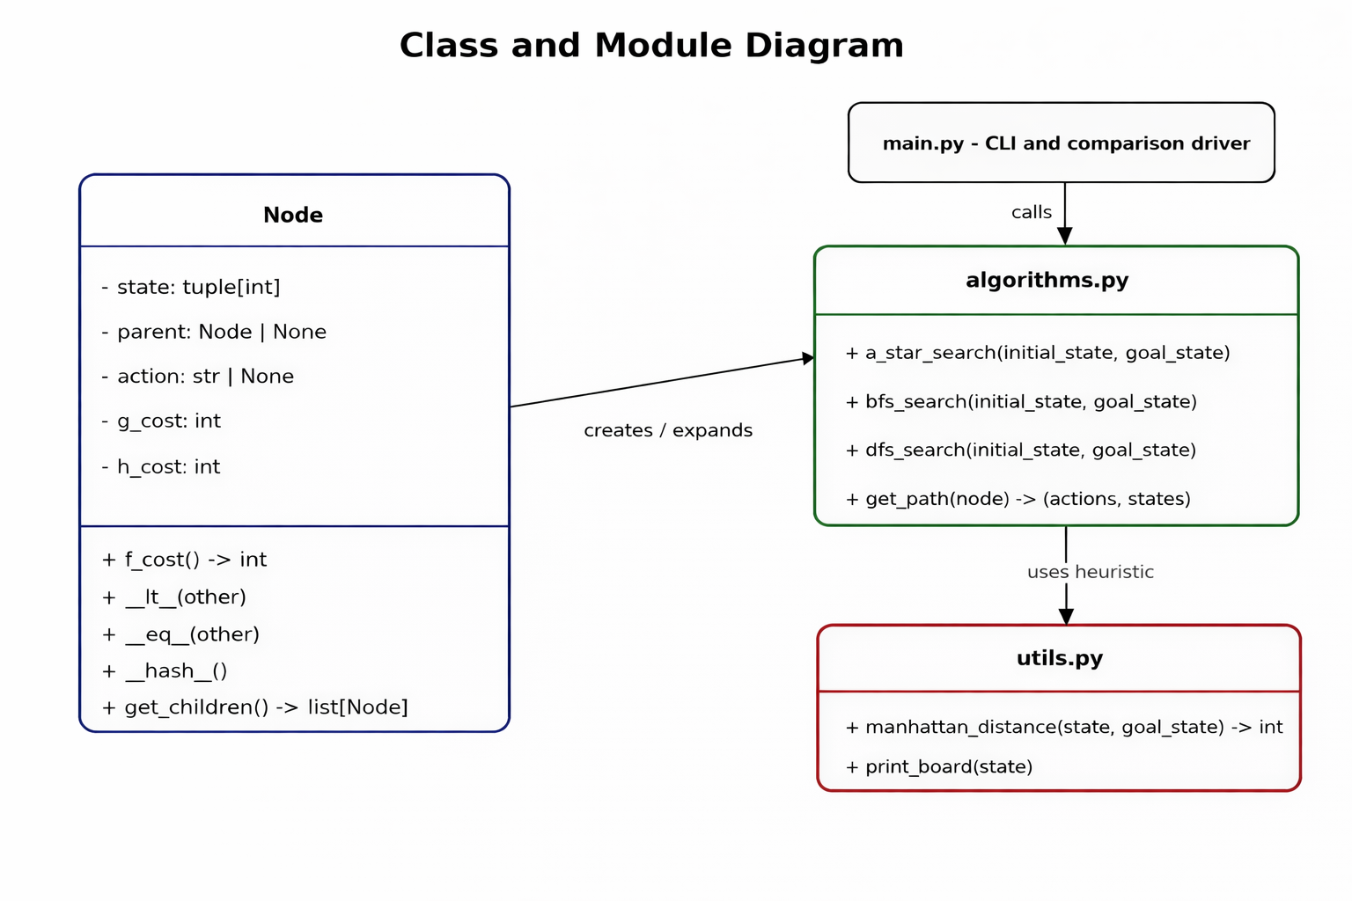
Figure 2. Updated class and module diagram derived from the final source files.

4.3 System architecture and data flow
The data flow begins in main.py, where the user either selects the default board or enters a custom state. After validation, main.py calls BFS, DFS, and A* from algorithms.py. The search procedures create Node objects through board.py, then request Manhattan distance values from utils.py whenever A* is running, and then returns the solved path and metrics back to the console for display.
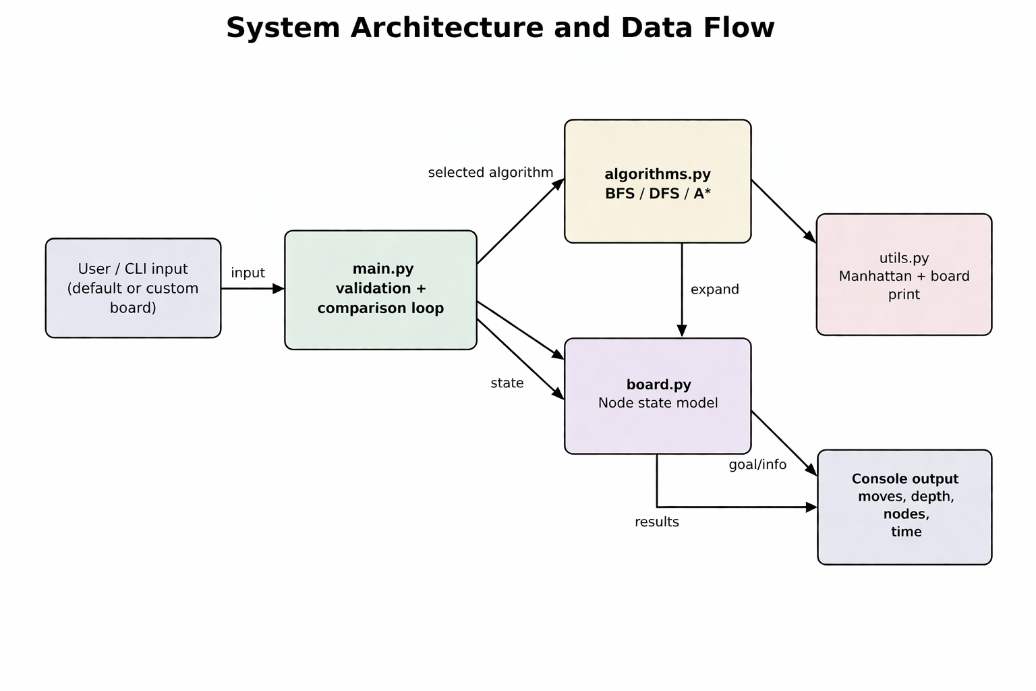
Figure 3. Updated architecture and data-flow view of the final implementation.

5. Experimental Evaluation
To evaluate the implementation and show the value of heuristic guidance, the solver was tested using a moderately difficult starting configuration (0, 1, 2, 3, 4, 5, 6, 7, 8). All three algorithms, Breadth-First Search, Depth-First Search, and A* Search were run on the same initial state for a comparison based on solution depth, number of nodes expanded, and execution time.

Algorithm | Solution Length | Nodes Expanded | Run Time (s)
A Search (Manhattan)* | 22 | 1,341 | ~0.01
Breadth-First Search (BFS) | 22 | 63,382 | ~0.20
Depth-First Search (DFS) | 10,978 | 172,559 | ~0.54
Table 1. Performance comparison of informed vs. uninformed search algorithms on a custom test board.
5.1 Interpretation of results
The results clearly demonstrate the advantage of informed search (A*) over uninformed strategies like BFS and DFS. Both A* and BFS found the optimal shortest path of 22 moves, but A* expanded only 1,341 nodes which is much fewer than BFS’s 63,382 nodes. This shows how the Manhattan distance heuristic effectively guided A* to the goal state while BFS expended resources exploring all directions evenly.

DFS performed the worst, producing a valid but highly inefficient solution of 10,978 moves and expanding over 172,000 nodes. Without heuristic guidance or level-based exploration, DFS blindly traversed many unnecessary states before reaching the goal. This comparison shows the critical role of AI heuristics in efficiently navigating complex search spaces.

6. Software Engineering Assessment
From a software engineering perspective, this project follows several good practices. The system is built with a clear modular structure, separating the state representation in board.py, adding the search algorithms in algorithms.py, including support functions in utils.py, and the main execution point in main.py. This structure makes the code easier to understand and follow.

The project also includes a user-friendly command line interface (CLI) in main.py and It also has an input-validation layer that helps catch common user mistakes. For example, it uses try-except blocks to avoid crashes caused by non-integer inputs and makes sure custom user boards have exactly nine unique digits from 0 to 8 before running.

To ensure reliability and streamline debugging, a custom automated test suite was created in tests/run_tests.py. This script automatically verifies the input validation logic against edge cases including invalid types, duplicate digits, and incorrect lengths.

7. Ethical and Professional Considerations
Even though the 8-puzzle is a relatively small and simple problem, it still reflects the kind of responsibilities that come with building real AI systems. A program like this should validate user input properly and avoid giving the impression that it always finds the best solution. For example, it’s important to point out that while DFS can find a solution, it may not be the most efficient one, and could take many more moves than necessary.

Another important factor is how resources are used. If the solver spends too much time exploring states that don’t lead anywhere or are unsolvable, it ends up wasting both time and computational power. Because of this, it’s important to be clear about the system’s limitations, present results in a straightforward way, and include features like solvability checks. These kinds of considerations help make the system more reliable and align it with good AI development practices.

8. Limitations and Future Work
- Add an inversion-parity solvability test before running search so unsolvable boards can be rejected immediately.
- Enhance A* by tracking states already in the frontier and storing the best known g_cost to reduce duplicate work.
- Extend the CLI to optionally print full intermediate board states step by step or provide a lightweight graphical interface.
- Record richer metrics such as maximum frontier size, memory usage, and average branching factor during execution.

9. Conclusion
The final project essentially delivers a complete 8-puzzle solver that includes BFS, DFS, and A* Search with Manhattan distance, together with an interactive main program for validation and algorithm comparison. The project demonstrates the role of state-space search in AI, shows why heuristic guidance matters, and satisfies the major reporting expectations for problem formulation, algorithm explanation, system design, experimental evaluation, software engineering assessment, and ethical reflection.
Overall, the results show that informed search methods can maintain optimal solutions while significantly reducing unnecessary exploration. With further improvements, such as adding solvability checks and enhancing frontier management, the system could be developed into a more efficient and polished 8-puzzle solver.

Appendix A. File Responsibilities
File | Primary Responsibility
src/board.py | Defines the Node class, stores state and cost values, and generates valid child states.
src/algorithms.py | Implements A*, BFS, DFS, and reconstructs the final solution path with get_path().
src/utils.py | Provides Manhattan distance and board-printing helper functions.
src/main.py | Acts as the primary entry point, validates user input, and runs the performance comparison between algorithms.
tests/run_tests.py | The automated test suite to verify input validation edge cases and algorithm accuracy.
.gitignore.txt | Repository housekeeping file used to exclude environment and generated files from version control.

